ព្រះរាជាណាចក្រកម្ពុជា

ជាតិ​ សាសនា ព្រះមហាក្សត្រ

Institute of technology of Cambodia

Department of Information and communication Engineering



The lesson taking about using structure in c++

TP12 using c++

TP: Algorithm and Programming ll

Lecturer: BOU CHANNA

Student: VEN THON

ID: e20191250

Group: I3-GIC-C

Year: 2022-2023

Contents

Problem1: 3

Problem2: 4

Proble3: 5

Problem4: 7

Problem5: 8

Problem6: 9

Problem7: 10

Problem8: 11

Problem9: 12

Problem10: 13

# Problem1:

Write a C++ program to ask information from a studentsuch as name, sex,major, age then display the greeting message on screen. “Hi, Mr. name, your age isageyear old and you learn major!”: for male (M)“

Hi, Mrs. name, you are ageyear old and you are majoring in major”: for female (F)

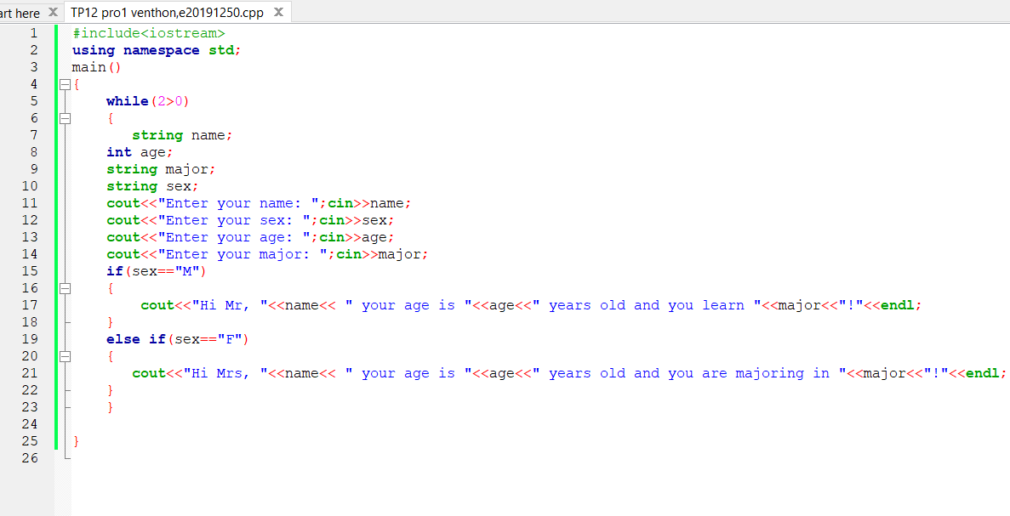

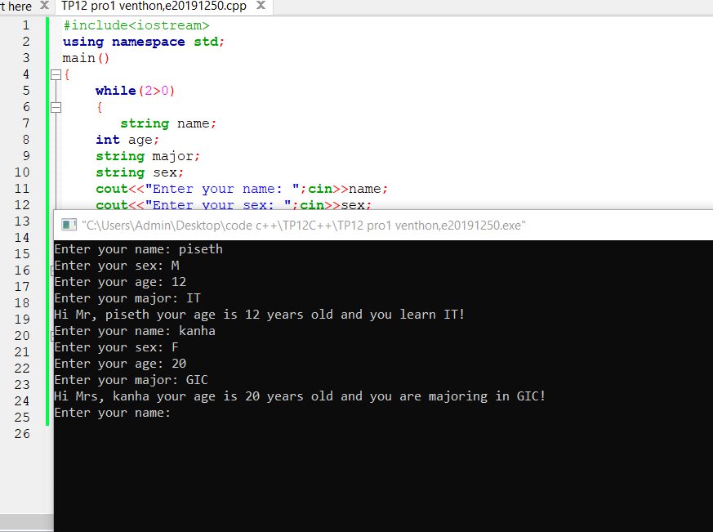

# Problem2:

Write a C++ program to check whether an input character is a vowel or a consonant.Hint: Use ASCII code to test condition.

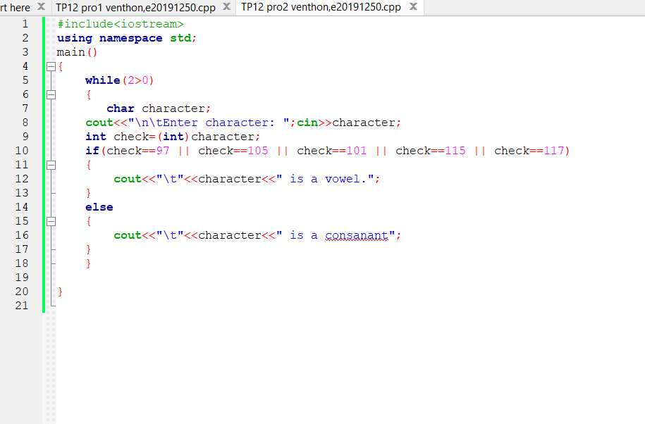

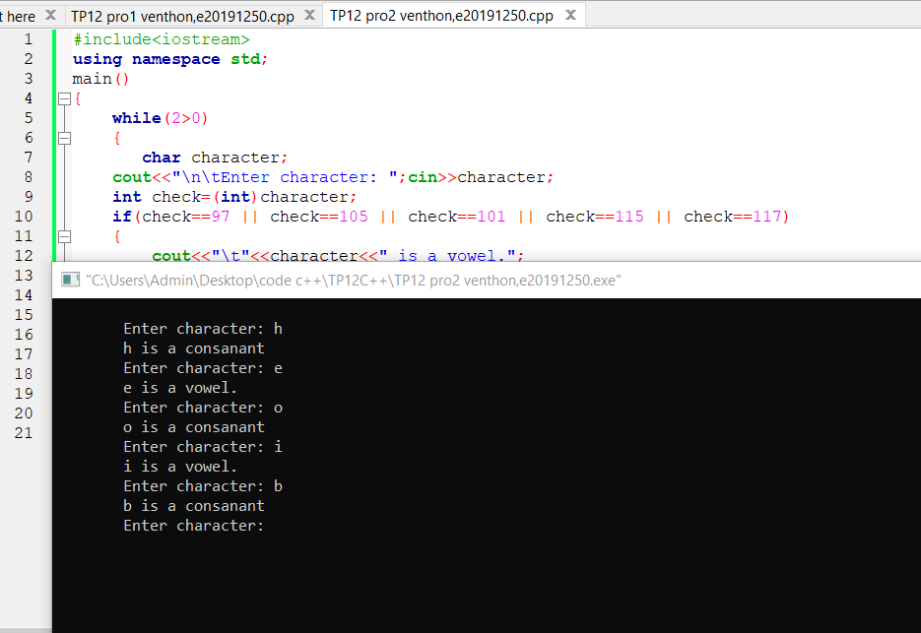

# Proble3:

A program to compute tax salaryof a person. The program asks forname, gender and salaryof a personand tell him/her how muchtax he/she is required to pay. The tax is computedbased on the rules below:

▪For males

•Salary more than 1000 USD, paytax10%

•Salary500 –1000 USD, pay tax 7%

•Salary less than 500 USD, pay tax 5%▪For

Females

•Salary more than 1000 USD, paytax8%

•Salary500 –1000 USD, pay tax 5%

•Salary less than 500 USD, pay tax 3%

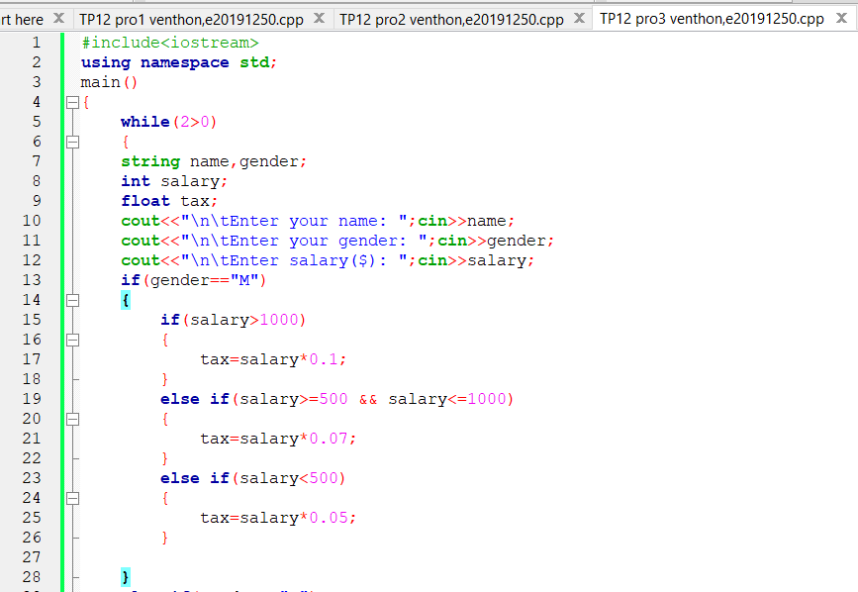

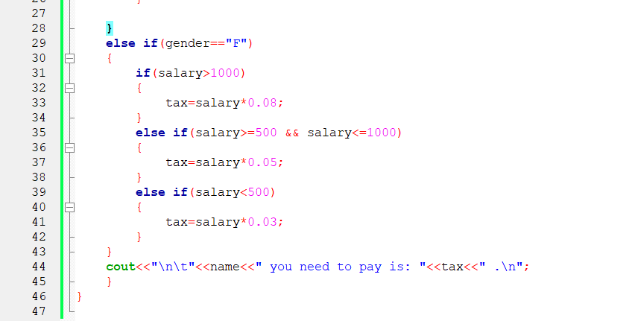

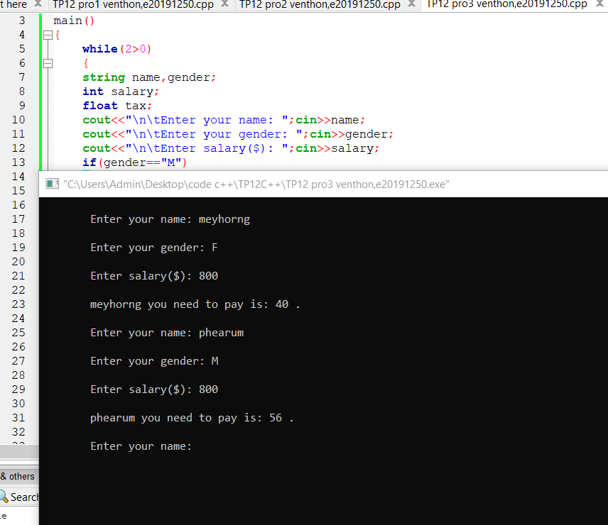

# Problem4:

Write a C++ program to convert a minuteto a time format which consists of hour, minute, and second (h:m:s). A user is required to input a minute.

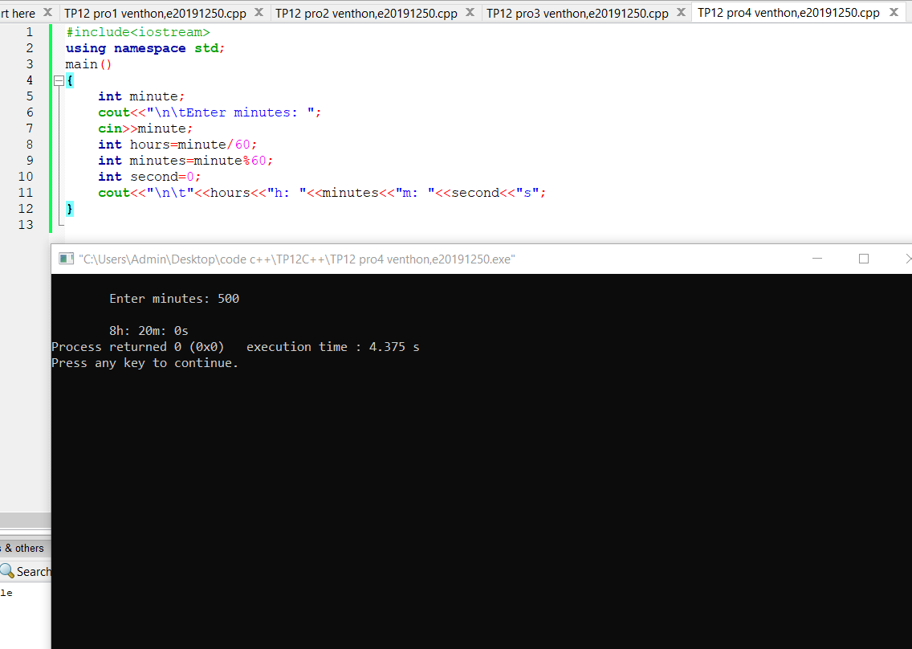

# Problem5:

Write a C++ program to find the summation of numbers from 1 to nexcept number10and 30,where n is a number input by a userand n should be greater than 50.

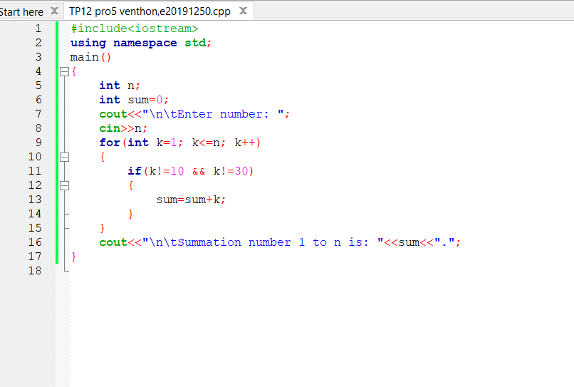

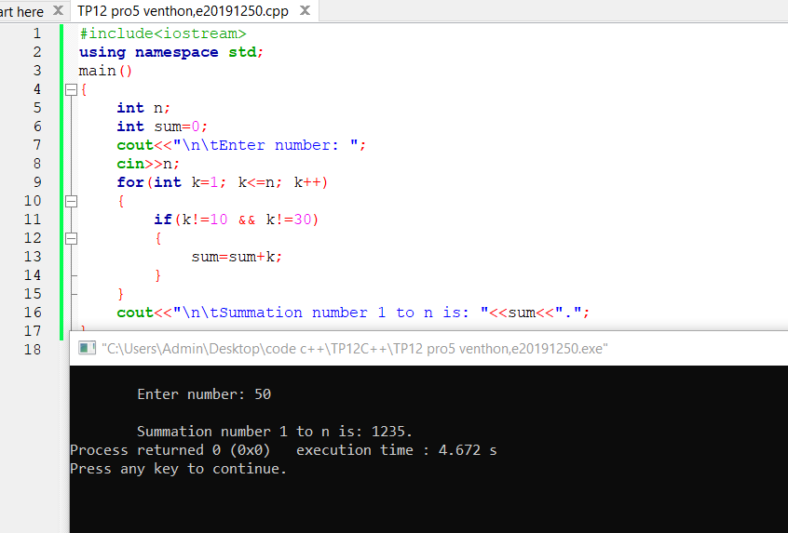

# Problem6:

Write a C++program to ask for an input character from a user and tell if that character is a number, an uppercase letter, or alowercase letter. If none of the above, displaya message “It is neithera number nor a letter”.

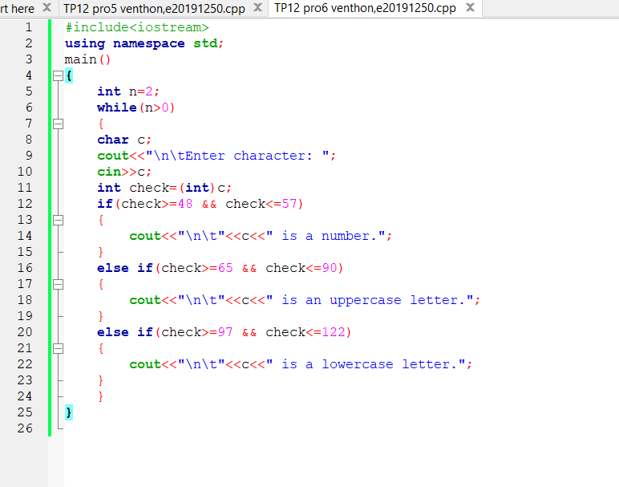

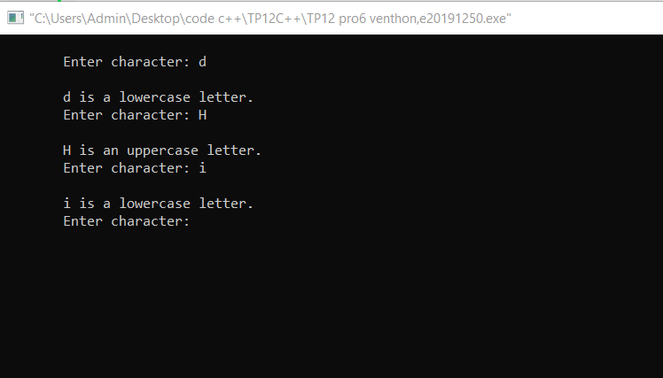

# Problem7:

A program to displayall integersdivisible by 5between 1 to 100 except 30, 60, and 90.

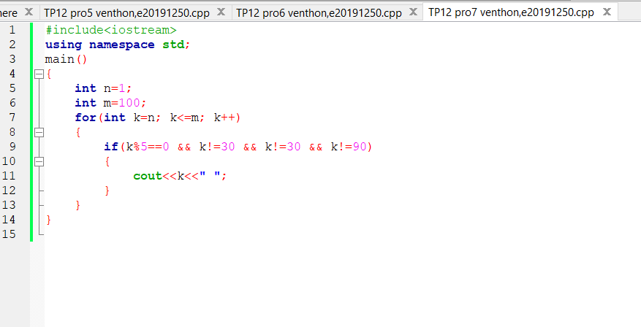

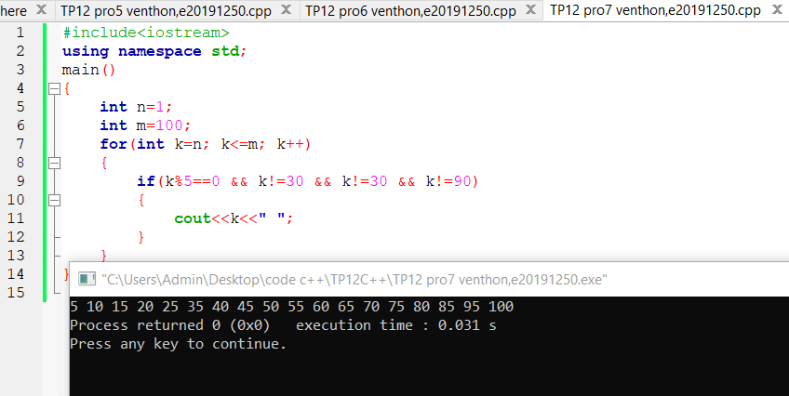

# Problem8:

Read 7inputintegernumbers from a user and find the minimumnumber as well as the maximum number.Then display them on screen.

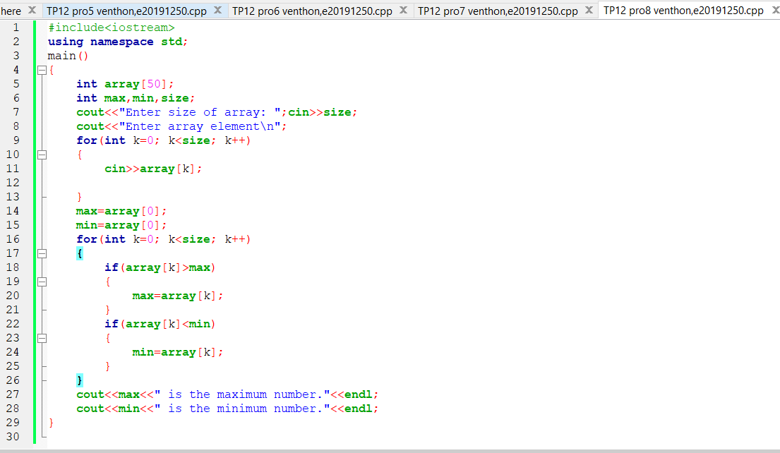

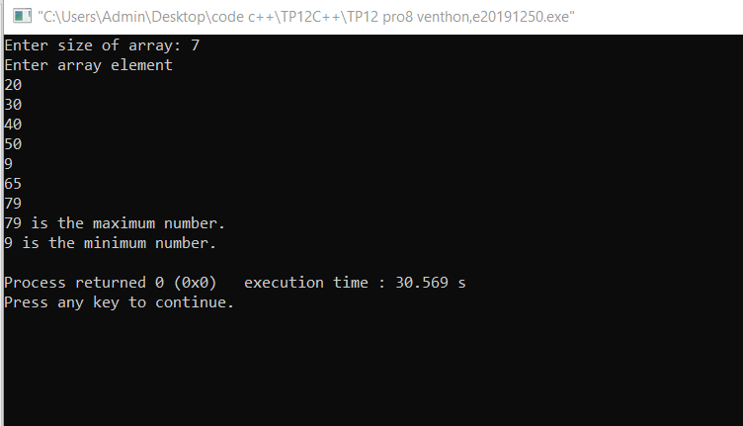

# Problem9:

Write a C++program to add all the numbers input by a user until the user inputs zero. Notice that a number is input one by one until user inputs zero, then display the summation and stop the program.

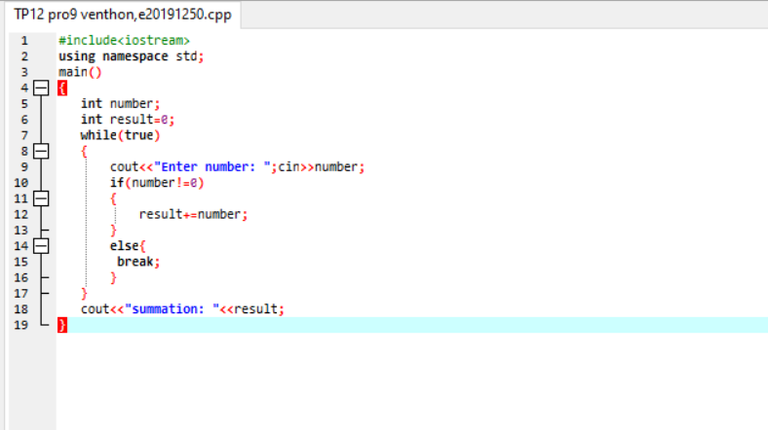

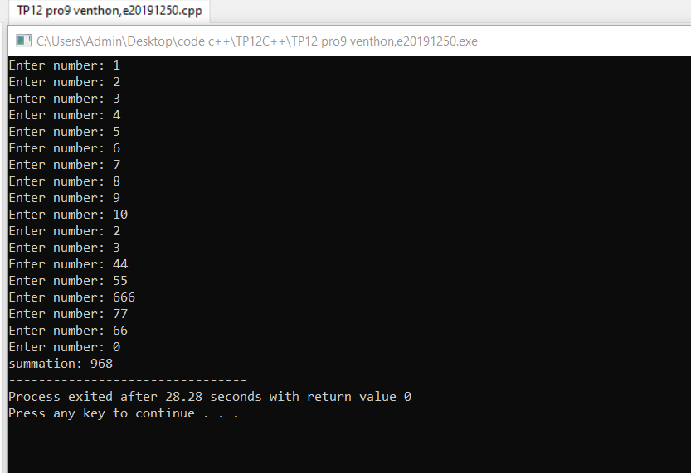

# Problem10:

Write aC++program to create a new data structure for storing info of book(book ID, book ISBN, book title,published year, authornamesandprice ($)).Each book could have more than one author. To do:

▪Create an array that can store 6books’ info.

▪Create a function to display a bookinfo based on ISBN. This function takesa parameter which is an ISBN of a book

.▪Create a function to display information of all books.

